Rolls Royces and art to dazzle at Suvretta House
Hotel Suvretta House, St Moritz, February 22, 6.30pm – 8.30pm.

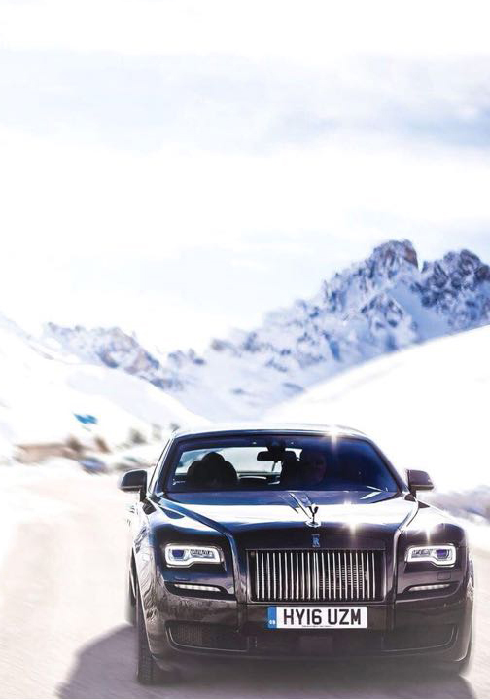
The world of luxury vehicles, brands and contemporary art are to be celebrated during a champagne reception at the Winter Lounge in St Moritz.
The world’s leading car brand, in collaborating with Bvlgari and the Art Jed Gallery, shall display during this prestigious occasion the beauty of the Dawn model, in a custom-made crystal cherry red finish, built with unparalleled Rolls-Royce craftsmanship.
The artistic centrepiece of the event will be Bolivian artist Sonia Falcone’s sculpture, Royal Love.
This is just one of the piece’s featured in the Art Jed Gallery’s inaugural exhibition which also includes works by Damien Hirst, Ellen von Unwerth, Terence Koh and other artists of international renown.
The Rolls Royce Arts Programme has a long history of supporting contemporary art, through which the brand honours the spirit of creative excellence that it shares with the art community.
It´s an honor that in just a few short weeks since opening, the Art Jed Gallery has been chosen by Rolls Royce to support this occasion. We want to make Art Jed Gallery a center piece of the international arts world and our association at this event with Rolls Royce and Bvlgari is another step towards that.”
Sonia Falcone, whose work is featured at Via Maistra gallery, is recognized as one of Latin America’s leading contemporary artists. She recently exhibited her art at the Palacio de Ajuda in Lisbon and the Nevada Museum of Art in the US, who purchased her very celebrated work ‘Campo de Color.’ In the coming month, Falcone shall be exhibiting at the Anchorage Museum in Alaska, US.
Falcone´s piece -Royal Love – is a creation using a plant found in the Bolivian Amazon rainforest that are then transformed it into a golden sculpture that stands on a stark black base.
According to Gabriel, “the visually-spectacular piece reminds us nature’s beauty, creativity and vitality will always match and inspire the creations of man, and that some of the most precious gifts we receive can emerge from the earth itself.”
The event will showcase beautiful cars, jewelry and art in a historical five-star setting.
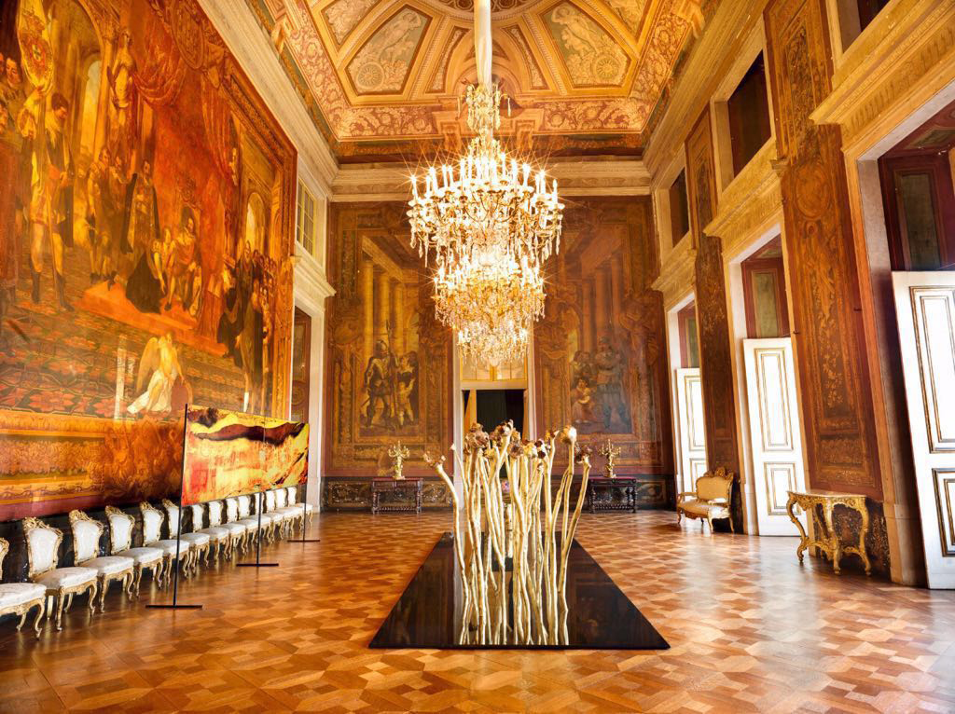
For further information on the event and the gallery please contact +41 76 431 70 67 or visit www.artjed.com. #RRwinterlounge / #RRWinterloungeArtjed.
RSVP info@artjed.com
About the artist:
Sonia Falcone is a contemporary Bolivian Latin American artist whose art incorporates social consciousness and activism. Her art is a vehicle for understanding the hardships of those marginalized as well as our shared global predicaments. Falcone has exhibited in London, New York, Boston, Miami, Washington, Dublin, Moscow, Venice, Monaco, Phoenix, Monterrey, La Paz, Santa Cruz, Bogota, Cabo San Lucas, Buenos Aires, Rio de Janeiro, Montevideo and Beijing.
About the gallery:
Art Jed Gallery, which opened in January, is a collaboration between philanthropist and art collector Artur Jedrzejewski – the CEO of Swiss wealth management firm Bouchard et Cie – and art curator Magdalena M. Gabriel, a future contemporaries member of London’s Serpentine Gallery and Museum.
Their aim is to present important works, and nurture the careers, of artists from across the globe in museum-scale exhibitions. Commercially, the gallery is committed to building distinguished art collections for clients by cultivating strong relationships with museums, institutions and auction houses worldwide to provide investors with collections of value and longevity based on provenance, placement and acquisition.

ART JED GALLERY 10 VIA MAISTRA SANKT MORITZ, 7500 SWITZERLAND +41 76 431 70 67

